|  |  |
| --- | --- |
| BRITISH COLUMBIA INSTITUTE OF TECHNOLOGY | Layout lab exercise |
| School of Computing and Academic Studies | COMP-4870 |
| Program: Computer Systems Technology | Due: At the end of the lab period |

# Lab: ASP.NET master pages, themes, and navigation

In this exercise, you will transform a crappy looking website named “MeltingPot” into an attractive site that it is built around ASP.NET’s master pages, ASP.NET navigation controls, and a themes.

## Step 1 – Examine the melting pot web site

1. Unzip the **MeltingPot.zip** file and open the “Melting Pot” web site in Visual Studio .NET. The web site was named “melting pot” because it is composed of a number of unrelated ASP.NET.
2. The home page and solution explorer are shown below:

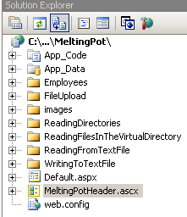

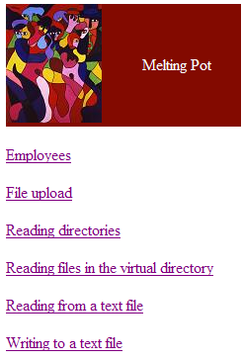

## Step 2 – Create a master page

1. Add a master page to the web application
2. Design a master page layout with the following regions:

banner region

nav

region Content region

1. Place the banner at the top in the banner region of the master page. You can achieve this by simply dragging and dropping the user control into the banner region.
2. Drag and drop a tree-view navigation control into the navigation region of the master page.
3. Add a “Site Map” item to the root of your web site. This is an XML file that you must edit so that it reflects the required navigation to the various pages of the site. Do not change the default name of the site map.
4. Drag and drop a **SiteMapDataSource** from the **Data** section of the toolbar to the bottom of the master page.
5. Change the **ShowStartingNode** property of the **SiteMapDataSource** to **false**.
6. Set the **DataSource** of the tree-view control to **SiteMapDataSource1**.
7. Your tree view navigation control should show some meaningful links.

### Step 3: Make all pages use the master page

All pages must be modified to use the master page. There are two ways to achieve this:

1. Add new pages while making sure that the **Select Master Page** checkbox is selected and the appropriate master page is chosen. You can then copy and paste the controls and code from the old page to the new page
2. Alternatively, you can modify all your pages by putting your controls into the markup similar to the following:

<%@ Page Language="C#"

MasterPageFile="~/MeltingPot.master"

AutoEventWireup="true"

CodeFile="Default2.aspx.cs"

Inherits="Default2"

Title="Untitled Page" %>

<asp:Content ID="Content1" ContentPlaceHolderID="ContentPlaceHolder1" Runat="Server">

</asp:Content>

NOTE:

* You must change all attributes of the directive to match your specific file and class names.
* Pages with inline code will not require the detective **CodeFile** & **Inherits** attributes.
* The old markup between (and not including) the <form> …. </form> tags are placed between the **asp:Content** opening and closing tags of a master page driven new web page.
* You do not need the header user control on every page anymore because it suffices to place the header once on the master page. Therefore, delete the user control from your new pages.
* Remove all the links on the root **Default.aspx** page as they are not needed anymore since the master page now furnishes us with all required navigation.

## Step 4: Apply the smoke & glass theme to your application

1. Create a new folder named **App_Themes** to the root of your web application.
2. Extract the **SmokeAndGlass.zip** file from week-10 lecture material into the newly created **App_Themes** folder.
3. Set the **Theme** property of all your aspx pages to **SmokeAndGlass**. This can be done through the Visual Studio designer or by simple adding **Theme="SmokeAndGlass"** to the @Page directive of every aspx page.

You are now done. The web application is now:

* much more attractive
* easily maintainable
* and easily brand-able

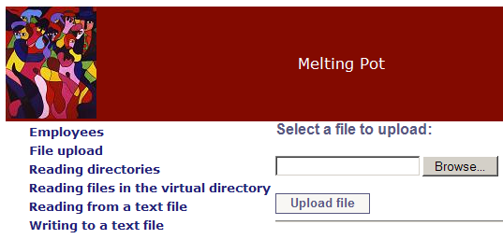

# COMP-4870 Layout lab exercise marking guide:

|  |  |  |
| --- | --- | --- |
| **Name ___________________________________________________ Set ______** | | |
| **Task** | **Max Mark** | **Actual Mark** |
| Step 2 – Create a master page | **3** |  |
| Step 3: Make all pages use the master page | **3** |  |
| Step 4: Apply the smoke & glass theme to your application | **2** |  |
| The web application works as intended | **2** |  |
| **TOTAL:** | **10** |  |